**Aaditee Agrawal (22bcs11305)**

**FL_IoT 601 ‘A’**

[**1. Binary Tree Inorder Traversal**](https://leetcode.com/problems/binary-tree-inorder-traversal/)

class Solution {

 public:

  vector<int> inorderTraversal(TreeNode* root) {

    vector<int> ans;

    stack<TreeNode*> stack;

    while (root != nullptr || !stack.empty()) {

      while (root != nullptr) {

        stack.push(root);

        root = root->left;

      }

      root = stack.top(), stack.pop();

      ans.push_back(root->val);

      root = root->right;

    }

    return ans;

  }

};

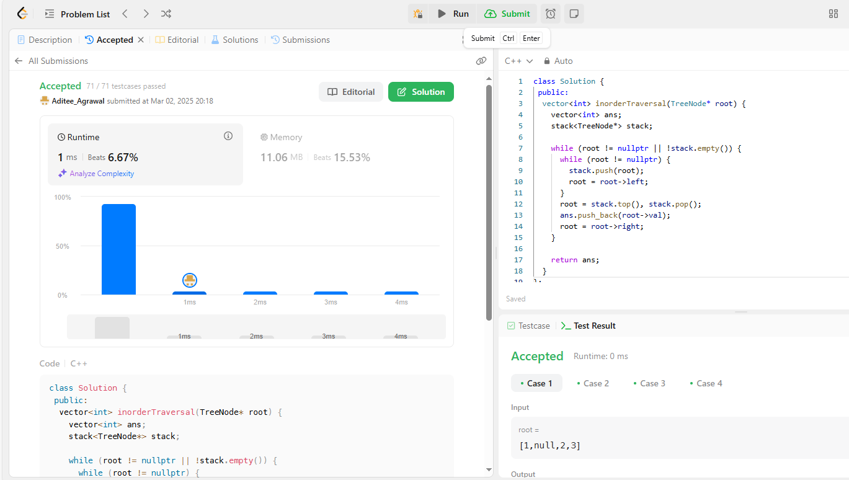

[**2. Symmetric Tree**](https://leetcode.com/problems/symmetric-tree/)

class Solution {

public:

bool isSymmetric(TreeNode* root) {

return isSymmetric(root, root);

}

private:

bool isSymmetric(TreeNode* p, TreeNode* q) {

if (!p || !q)

return p == q;

return p->val == q->val && //

isSymmetric(p->left, q->right) && //

isSymmetric(p->right, q->left);

}

};

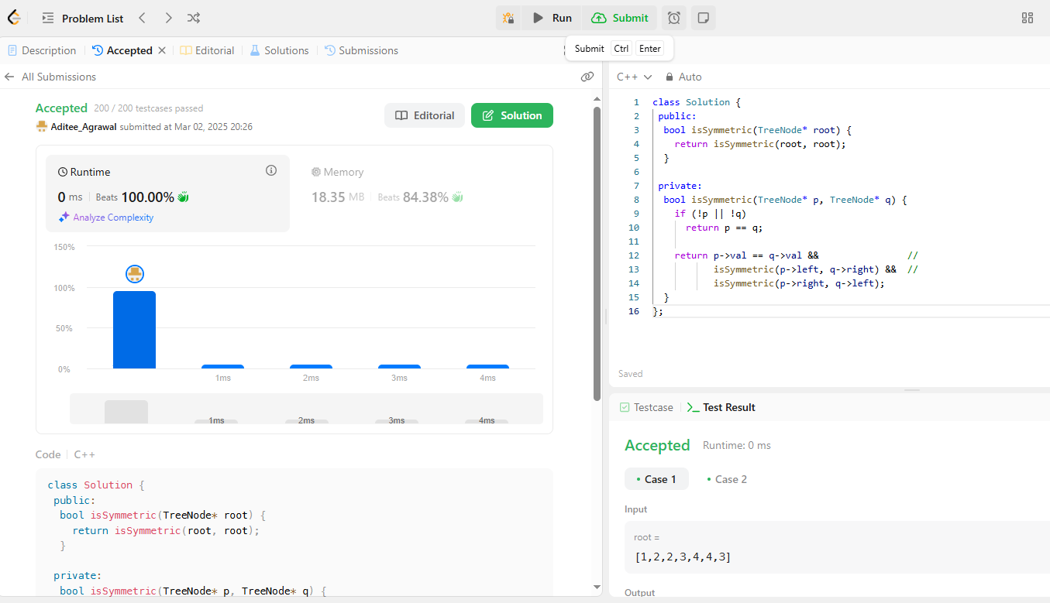

**3** .[Maximum Depth of Binary Tree](https://leetcode.com/problems/maximum-depth-of-binary-tree/description/)

class Solution {

public:

int maxDepth(TreeNode* root) {

if (root == nullptr)

return 0;

return 1 + max(maxDepth(root->left), maxDepth(root->right));

};

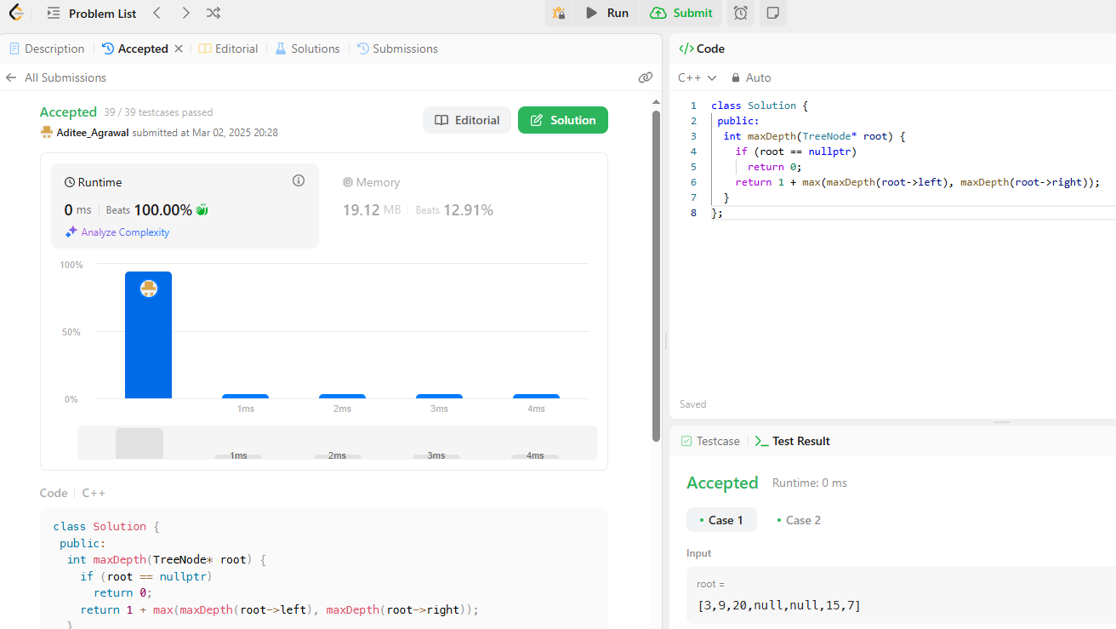

**4.** [Validate Binary Search Tree](https://leetcode.com/problems/validate-binary-search-tree/description/)

class Solution {

public:

bool isValidBST(TreeNode* root) {

return isValidBST(root, nullptr, nullptr);

}

private:

bool isValidBST(TreeNode* root, TreeNode* minNode, TreeNode* maxNode) {

if (root == nullptr)

return true;

if (minNode && root->val <= minNode->val)

return false;

if (maxNode && root->val >= maxNode->val)

return false;

return isValidBST(root->left, minNode, root) &&

isValidBST(root->right, root, maxNode);

}

};

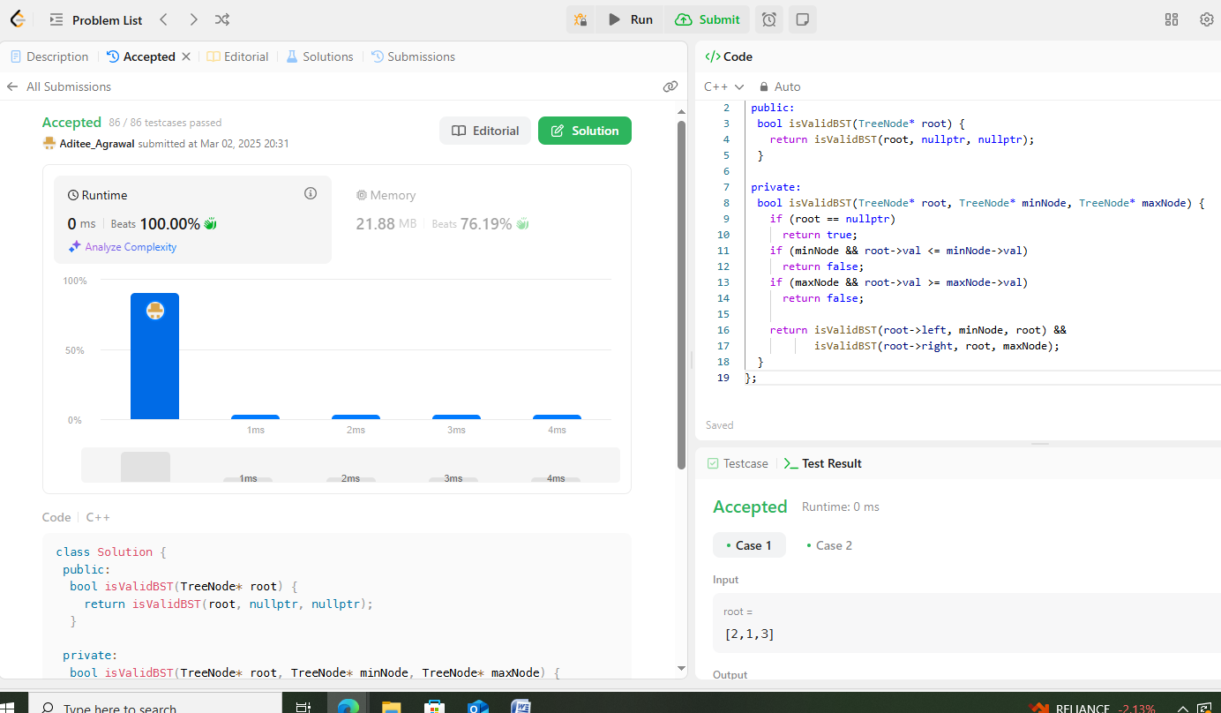

5.[Kth Smallest Element in a BST](https://leetcode.com/problems/kth-smallest-element-in-a-bst/description/)

class Solution {

 public:

  int kthSmallest(TreeNode* root, int k) {

    const int leftCount = countNodes(root->left);

    if (leftCount == k - 1)

      return root->val;

    if (leftCount >= k)

      return kthSmallest(root->left, k);

    return kthSmallest(root->right, k - 1 - leftCount);  // leftCount < k

  }

 private:

  int countNodes(TreeNode* root) {

    if (root == nullptr)

      return 0;

    return 1 + countNodes(root->left) + countNodes(root->right);

  }

};

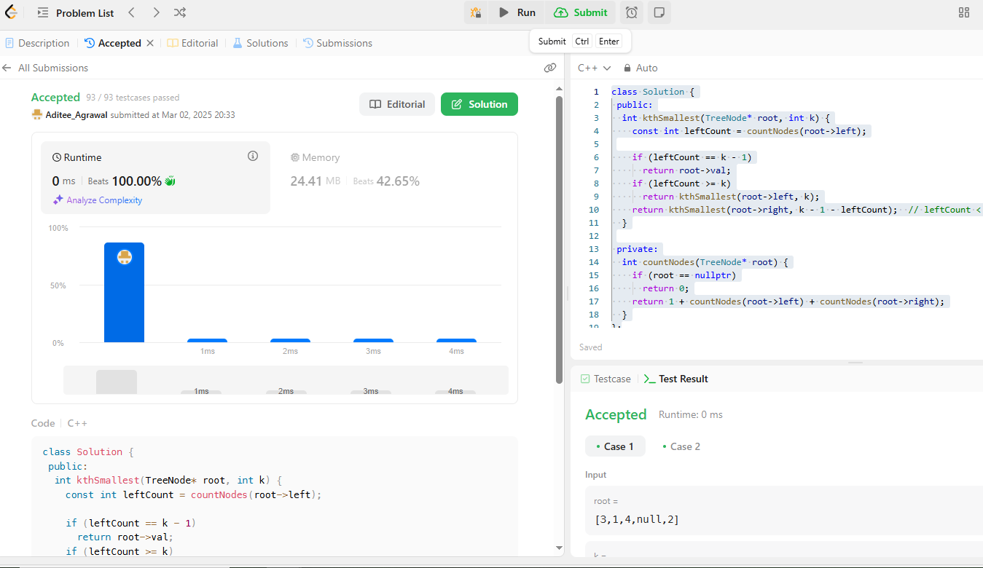

**6.**[Binary Tree Level Order Traversal](https://leetcode.com/problems/binary-tree-level-order-traversal/description/)

class Solution {

public:

vector<vector<int>> levelOrder(TreeNode* root) {

if (root == nullptr)

return {};

vector<vector<int>> ans;

queue<TreeNode*> q{{root}};

while (!q.empty()) {

vector<int> currLevel;

for (int sz = q.size(); sz > 0; --sz) {

TreeNode* node = q.front();

q.pop();

currLevel.push_back(node->val);

if (node->left)

q.push(node->left);

if (node->right)

q.push(node->right);

}

ans.push_back(currLevel);

}

return ans;

}

};

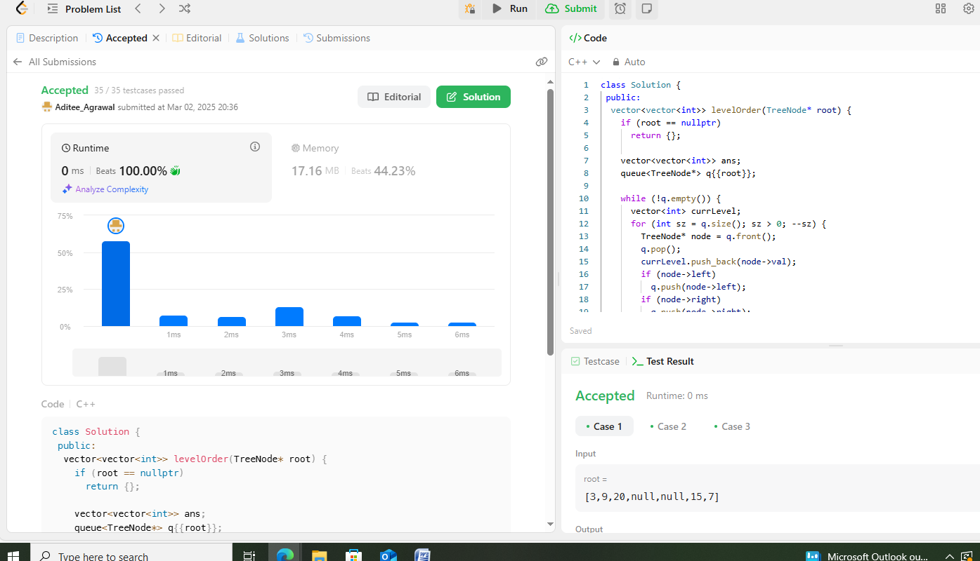

7. [Binary Tree Level Order Traversal II](https://leetcode.com/problems/binary-tree-level-order-traversal-ii/description/)

class Solution {

public:

vector<vector<int>> levelOrderBottom(TreeNode* root) {

if (root == nullptr)

return {};

vector<vector<int>> ans;

queue<TreeNode*> q{{root}};

while (!q.empty()) {

vector<int> currLevel;

for (int sz = q.size(); sz > 0; --sz) {

TreeNode* node = q.front();

q.pop();

currLevel.push_back(node->val);

if (node->left)

q.push(node->left);

if (node->right)

q.push(node->right);

}

ans.push_back(currLevel);

}

ranges::reverse(ans);

return ans;

}

};

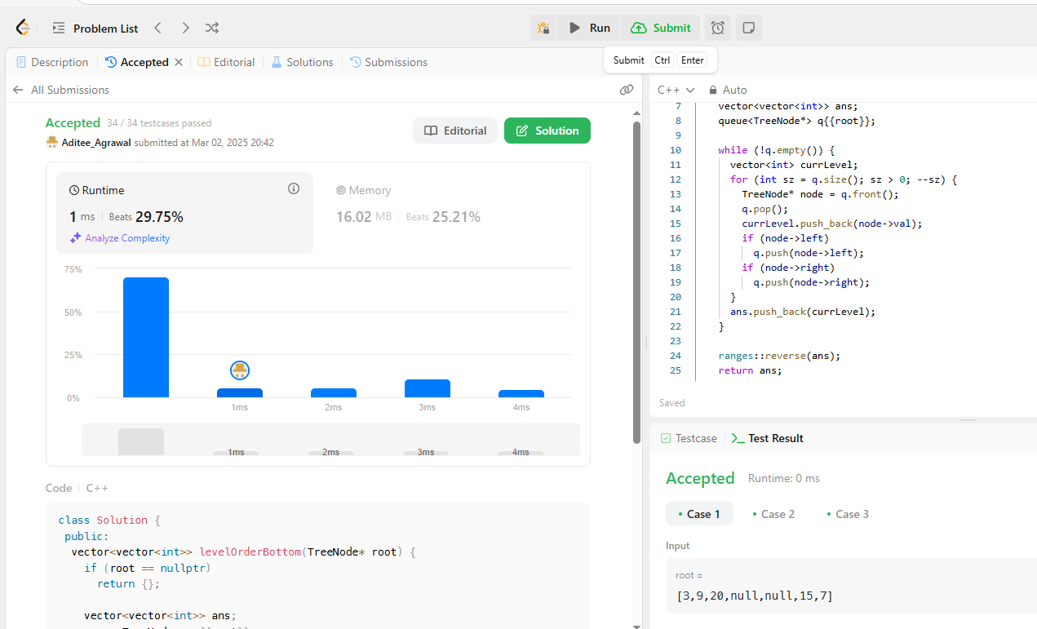

8. .[Binary Tree Zigzag Level Order Traversal](https://leetcode.com/problems/binary-tree-zigzag-level-order-traversal/description/)

class Solution {

public:

vector<vector<int>> zigzagLevelOrder(TreeNode* root) {

if (root == nullptr)

return {};

vector<vector<int>> ans;

deque<TreeNode*> dq{{root}};

bool isLeftToRight = true;

while (!dq.empty()) {

vector<int> currLevel;

for (int sz = dq.size(); sz > 0; --sz)

if (isLeftToRight) {

TreeNode* node = dq.front();

dq.pop_front();

currLevel.push_back(node->val);

if (node->left)

dq.push_back(node->left);

if (node->right)

dq.push_back(node->right);

} else {

TreeNode* node = dq.back();

dq.pop_back();

currLevel.push_back(node->val);

if (node->right)

dq.push_front(node->right);

if (node->left)

dq.push_front(node->left);

}

ans.push_back(currLevel);

isLeftToRight = !isLeftToRight;

}

return ans;

}

};

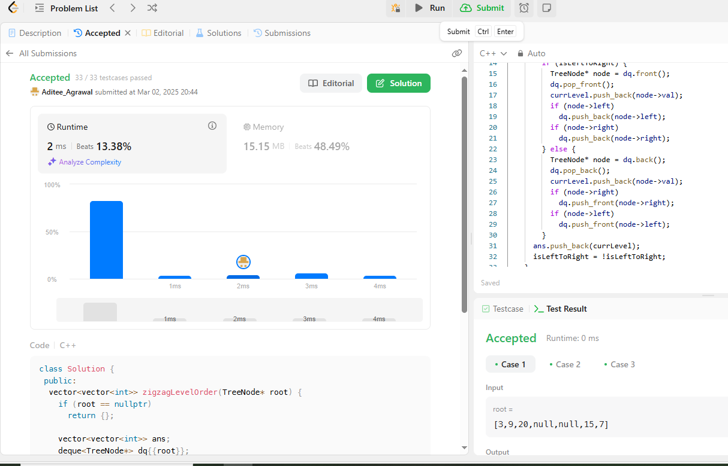

9. [Binary Tree Right Side View](https://leetcode.com/problems/binary-tree-right-side-view/description/)

class Solution {

public:

vector<int> rightSideView(TreeNode* root) {

if (root == nullptr)

return {};

vector<int> ans;

queue<TreeNode*> q{{root}};

while (!q.empty()) {

const int size = q.size();

for (int i = 0; i < size; ++i) {

TreeNode* node = q.front();

q.pop();

if (i == size - 1)

ans.push_back(node->val);

if (node->left)

q.push(node->left);

if (node->right)

q.push(node->right);

}

}

return ans;

}

};

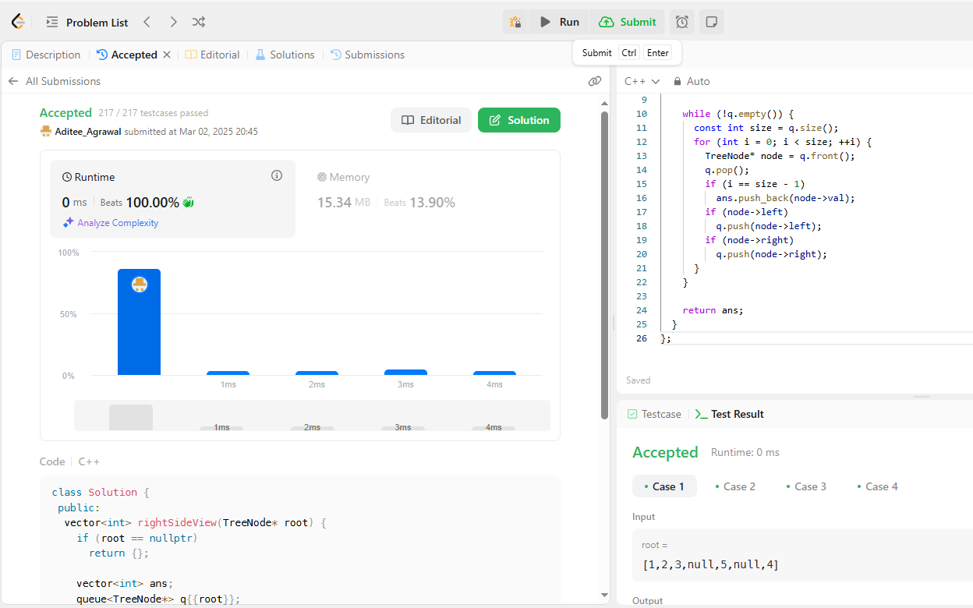

10. [Construct Binary Tree from Inorder and Postorder Traversal](https://leetcode.com/problems/construct-binary-tree-from-inorder-and-postorder-traversal/description/)

class Solution {

public:

TreeNode* buildTree(vector<int>& inorder, vector<int>& postorder) {

unordered_map<int, int> inToIndex;

for (int i = 0; i < inorder.size(); ++i)

inToIndex[inorder[i]] = i;

return build(inorder, 0, inorder.size() - 1, postorder, 0,

postorder.size() - 1, inToIndex);

}

private:

TreeNode* build(const vector<int>& inorder, int inStart, int inEnd,

const vector<int>& postorder, int postStart, int postEnd,

const unordered_map<int, int>& inToIndex) {

if (inStart > inEnd)

return nullptr;

const int rootVal = postorder[postEnd];

const int rootInIndex = inToIndex.at(rootVal);

const int leftSize = rootInIndex - inStart;

TreeNode* root = new TreeNode(rootVal);

root->left = build(inorder, inStart, rootInIndex - 1, postorder, postStart,

postStart + leftSize - 1, inToIndex);

root->right = build(inorder, rootInIndex + 1, inEnd, postorder,

postStart + leftSize, postEnd - 1, inToIndex);

return root;

}

};

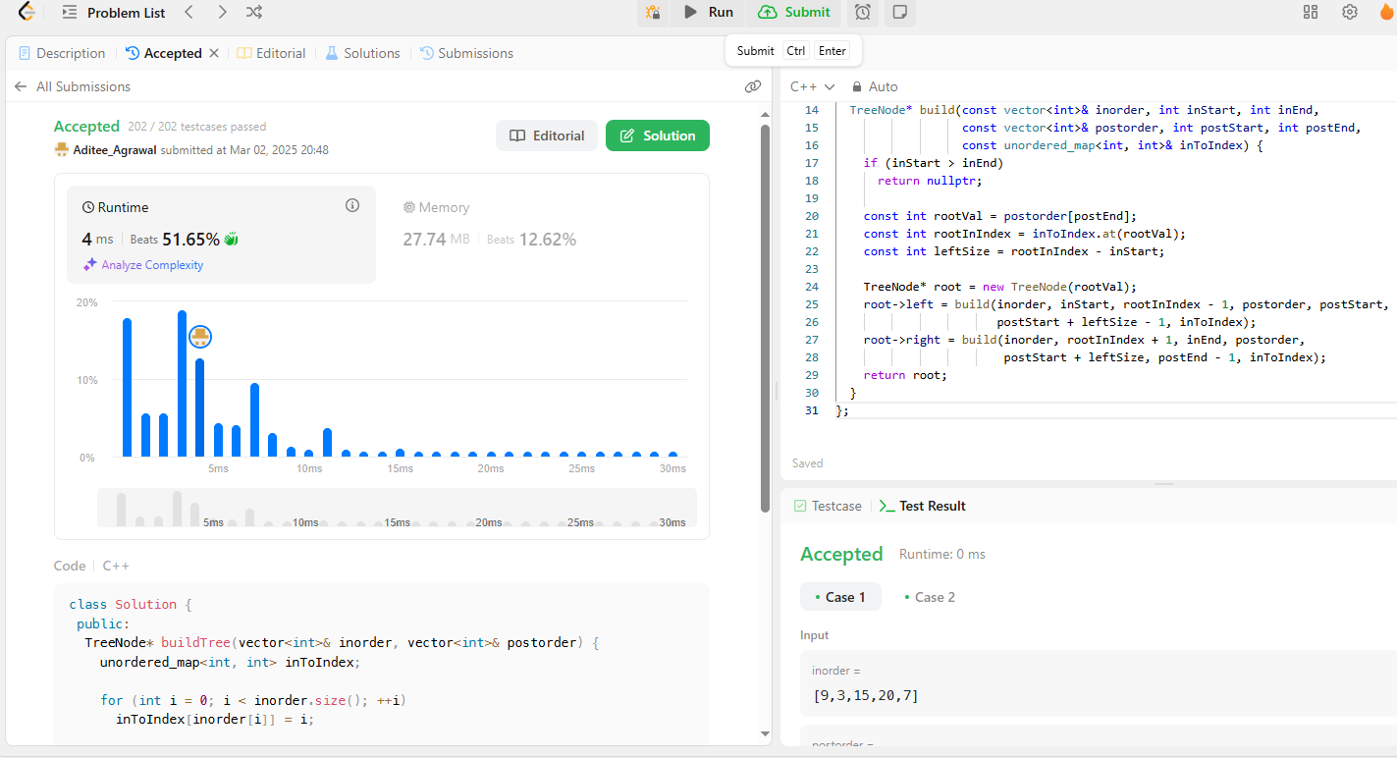

11. [Find Bottom Left Tree Value](https://leetcode.com/problems/find-bottom-left-tree-value/description/)

class Solution {

public:

int findBottomLeftValue(TreeNode* root) {

queue<TreeNode*> q{{root}};

TreeNode* node = nullptr;

while (!q.empty()) {

node = q.front();

q.pop();

if (node->right)

q.push(node->right);

if (node->left)

q.push(node->left);

}

return node->val;

}

};

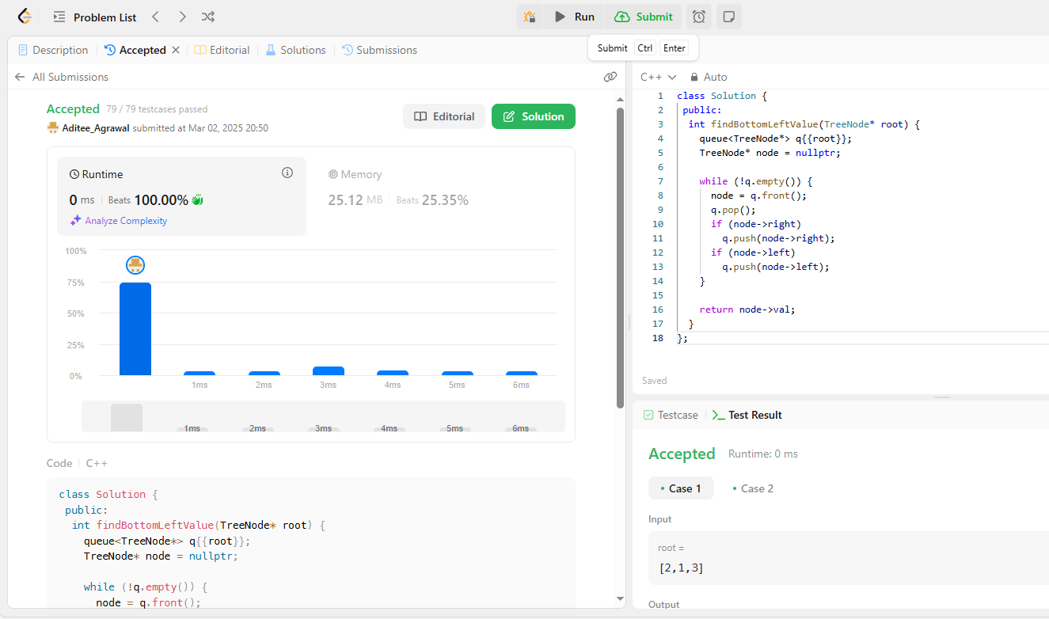

12. [Binary Tree Maximum Path Sum](https://leetcode.com/problems/binary-tree-maximum-path-sum/description/)

class Solution {

 public:

  int maxPathSum(TreeNode* root) {

    int ans = INT_MIN;

    maxPathSumDownFrom(root, ans);

    return ans;

  }

 private:

  int maxPathSumDownFrom(TreeNode* root, int& ans) {

    if (root == nullptr)

      return 0;

    const int l = max(0, maxPathSumDownFrom(root->left, ans));

    const int r = max(0, maxPathSumDownFrom(root->right, ans));

    ans = max(ans, root->val + l + r);

    return root->val + max(l, r);

  }

};

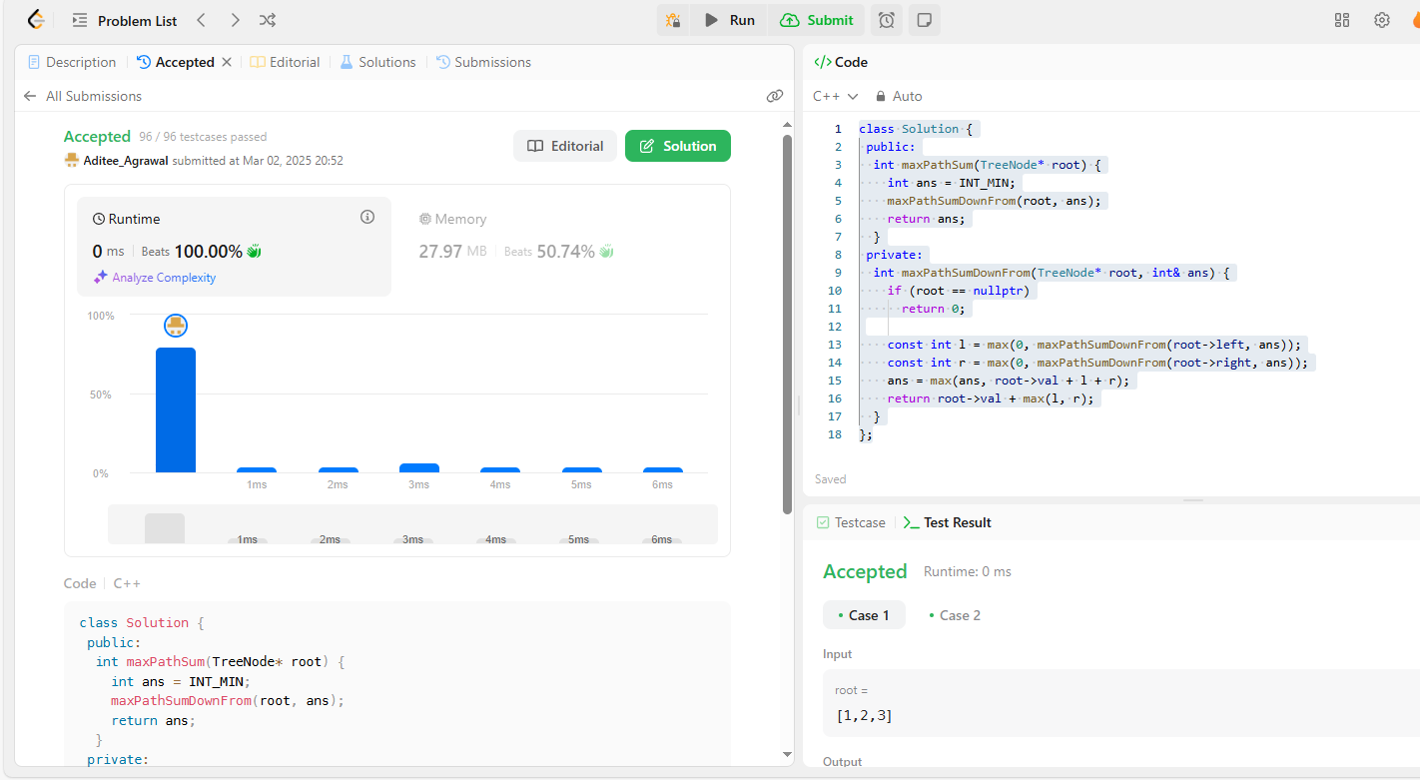

13. .[Vertical Order Traversal of a Binary Tree](https://leetcode.com/problems/vertical-order-traversal-of-a-binary-tree/description/)

class Solution {

 public:

  vector<vector<int>> verticalTraversal(TreeNode* root) {

    vector<vector<int>> ans;

    map<int, multiset<pair<int, int>>> xToSortedPairs;

    dfs(root, 0, 0, xToSortedPairs);

    for (const auto& [_, pairs] : xToSortedPairs) {

      vector<int> vals;

      for (const pair<int, int>& pair : pairs)

        vals.push_back(pair.second);

      ans.push_back(vals);

    }

    return ans;

  }

 private:

  void dfs(TreeNode* root, int x, int y,

           map<int, multiset<pair<int, int>>>& xToSortedPairs) {

    if (root == nullptr)

      return;

    xToSortedPairs[x].emplace(y, root->val);

    dfs(root->left, x - 1, y + 1, xToSortedPairs);

    dfs(root->right, x + 1, y + 1, xToSortedPairs);

  }

};

